SUSTAINABLE DEVELOPMENT SOLUTIONS NETWORK -KENYA
P.O BOX 3900 – ELDORET, KENYA
Tel: (+254)722231255/722626286/722992107
Website: www.kenya.unsdsn.org Email:kenya@unsdsn.org

Activity summary report

Activity: integrating Health and fitness (Yoga) skills into achieving UN Goal 8: Decent work and economic growth.
Activity background
Over the past 25 years the number of workers living in extreme poverty has declined dramatically, despite the lasting impact of the 2008 economic crisis and global recession. In developing countries, the middle class now makes up more than 34 percent of total employment – a number that has almost tripled between 1991 and 2015.
However, as the global economy continues to recover we are seeing slower growth, widening inequalities, and not enough jobs to keep up with a growing labour force. According to the International Labour Organization, more than 204 million people were unemployed in 2015.
The SDGs promote sustained economic growth, higher levels of productivity and technological innovation. Encouraging entrepreneurship and job creation are key to this, as are effective measures to eradicate forced labour, slavery and human trafficking. With these targets in mind, the goal is to achieve full and productive employment, and decent work, for all women and men by 2030. Goal 8: Decent work and economic growth | UNDP
"Good Health and Well-being", is also one of the 17 Sustainable Development Goals established by the United Nations in 2015. The official wording is: "To ensure healthy lives and promote well-being for all at all ages." The targets of SDG 3 cover and focus on various aspects of healthy life and healthy lifestyle. Progress towards the targets is measured using twenty-one indicators.
Activity Justification
To achieve a healthy life and lifestyle, physical exercising with a combination of healthy eating habits forms a critical bath towards the attainment of SDG3 and one of the globally accepted forms of physical exercising is using Yoga skills which have to be transferred by a skilled trainer. In this context, Moi University through its SDSN Kenya Youth Initiative led by the Network coordinator in collaboration with Gratia Christian College’s school of business under the headship of Dr. Shirley Yeung and with mobilization support from Women Empowerment Group (WEG), established an implementation strategy to youth in Kenya gain health and wellness skills as well as by integrating goal 8 on decent work and economic growth.

Activity summary
This was the 2nd session of the series of youth empowerment and development activities under the collaboration and support from Dr. Shirley Yeung of Gratia Christian college who doubles up SDSN Kenya Asia Ambassador and a key partner of Women Empowerment Group and SDSN Kenya Youth Initiative,
The activity brought together another cohort of 15 female youth who were mobilized courtesy of SDSN Kenya Youth Initiative and Women Empowerment Group . It began with an intensive exercising and practicing Yoga moves and skills; a session moderated by SDSN Kenya Network coordinator and with assistance from facilitators from Women Empowerment group and Eldoret Falcons Football team.
Key Assignment
Participants where give an assignment to take home and this assignment indented to generate abstract business ideas from the participant which the planners and the implementers can explore further to train the participants on business plan development that will lead to them venturing into entrepreneurship.
The Key Challenge Question: ‘How best who you utilize USD100’?
Instructions:
- Think of a small but potentially viable business idea that can be started with the above amount, write it down in paper and do a budget within the budget ceiling and then share in our next session.
Next steps:
- We expect that in our session we will be able to learn a lot from the expected business ideas that would be able to inform our next steps in our life and health skills transfer program.
- From the outcome from the next 3rd session, we hope to plan and implement a formal training session that will involve the sponsor, the partners and implementers. This session will be both physical and virtual.
Opportunities
Our opportunities were still the same activity include;
- Willingness to learn – The female youth expressed there willingness to learnt and to continue practicing the skills until when they are acquainted to train other young girls in their communities.
- Availability of the youth – Due to the impact of Covid-19 most youth are at home and thus easy to access and mobilize them for an activity.
- Literacy levels – Majority of the female youth who were engaged
- Lack of knowledge on SDGs and vision 2030 in Kenya
Challenges
The implementation of this activity won’t happen without facing challenges and some of the challenges we experienced include;
- Lack of financial resources to plan for a better venue and commit qualified instructors as facilitators of the session.
- Covid-19 restrictions –We were unable to recruit more youth from far Counties due to associated ministry of health restriction for the containment of covid-19 pandemic.
Conclusion;
The session was optimistic that the next steps/session would be able to transform their lives. See the session photos;
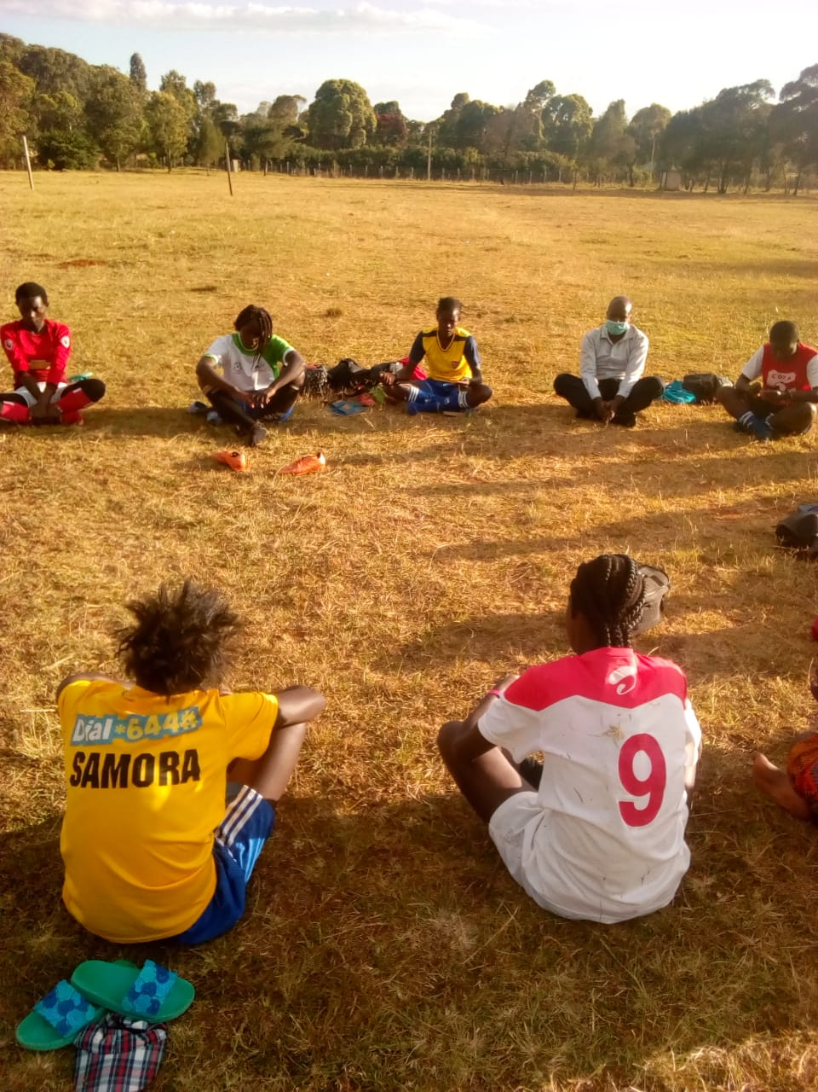
Myself wearing a mask) with the participant during 2nd session.

